**Sprint 1 Plan**

**Product name:** Peergrader

**Team name**: Peergrader

**Sprint completion date:** Apr 23, 2024

**Revision number:** 1

**Revision date:** Apr 11, 2024

**Goal:** Create auth backend, login screen, landing page, file upload, course creation

Maximum total hours/story points per Sprint: 60

**User Stories:**

As a student I want to be able to:

1. User story 1.1 [20 story points] See my dashboard with my courses and assignments that I need to complete in an organized manner.

As a professor I want to:

1. User story 1.2 [15 story points] Create a course and see all the students in my course.
2. User story 1.3 [15 Story Points] Create an assignment with a specific rubric per assignment and assign to a course.

As a professor and student I want to be able to

1. User story 1.4 [10 story points] Login with different account types

**Tasks Listing:**

User story 1.1

* Login and create auth connection with database
* Join a course
* Link courses and assignments to see more information
* Layout information in an easy to read manner

User story 1.2

* Login and create auth connection with database
* Create a course by clicking the add icon
* Name the course and create a join code, then publish
* Layout all courses on dashboard and link assignments, students, and settings per course

User story 1.3

* Make a create assignment page for the instructor
* Add name, deadlines, point assignment, anonymous grading toggle
* Add a rubric personalized to the assignment

User story 1.4

* Create landing page for user to choose to login or sign up
* Connect google for sign in with google
* Connect gitlab for sign in with gitlab

**Infrastructure:**

* Auth: Supabase
* Postgresql database: Supabase
* Storage (files): Supabase
* Deployment: Vercel
* GitHub: Version control
* Framework: next.js

**Team roles:**

* Christian Knab: SCRUM Master
* Aastha Verma: Team member
* Eliah Reeves: Product owner
* Eric Chuang: Team member

**Initial task assignment:**

* Aastha Verma: UI for landing page
* Eliah Reeves: User Story 1.1&2, login and create authentication
* Christian Knab: User Story 1.3 Instructor create an assignment
* Eric Chuang: User Story 1.2 Name a course and create join code

**Burnup Chart:**

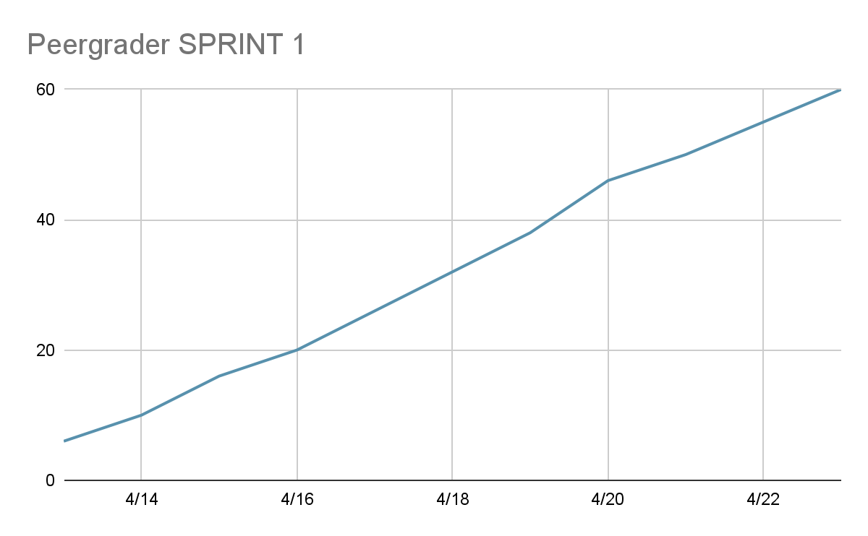

**SCRUM board**

| **User Story** | **Not Starter** | **In Progress** | **Done** |
| --- | --- | --- | --- |
| See my dashboard with my courses and assignments that I need to complete in an organized manner. | Link courses and assignments to see more information  Layout information in an easy to read manner |  | Login and create auth connection with database  Join a course |
| Create a course and see all the students in my course. | Layout all courses on dashboard and link assignments, students, and settings per course | Create a course by clicking the add icon  Create a join code | Login and create auth connection with database  Name the course, then publish |
| Create an assignment with a specific rubric per assignment and assign to a course. |  | Add name, deadlines, point assignment, anonymous grading toggle  Add a rubric personalized to the assignment | Make a create assignment page for the instructor |
| Login with different account types. | Connect gitlab for sign in with gitlab | Connect google for sign in with google | Create landing page for user to choose to login or sign up |

**Schedule of Scrum meetings**

* When: Mon/Wed/Fri 9am-11am
* Where: Jack’s Lounge Baskin Engineering
* TA meeting: Monday 11-12pm ZOOM